Pilgrim Primary Academy
Oxford Street, Plymouth, PL1 5BQ
Tel: 01752 225319
E-mail: contactus@ppsonline.org
Headteacher: Mrs L Meek (BA Hons, PGCE, N.P.Q.H)

9th May 2022
Dear Parents and Carers,
Welcome to the Summer Term and apologies for this Newsletter being sent out after the weekend but on Friday there was a problem with broadband in this area and the school internet was down. Thank you for your patience if you were trying to contact us in the afternoon – we had no email, text or phone services for the duration.
We are looking forward to a busy term, resuming some of our usual summer activities such as having our sports days, getting children out and about on trips and visits and finally have our Summer Fayre again (please see below about how you could join our PTFA team to make sure this event is a roaring success!). At the end of the year, teachers will be sending out the pupil Annual Reports which will summarise your child’s progress and attainment for the year. We will finish our year with our annual Governors’ Awards in which our Governors recognise a range of achievements across all year groups.
It is a bumper edition Newsletter this week, with lots of information about the term ahead…happy reading!
School Messages
New building - KS2 playground
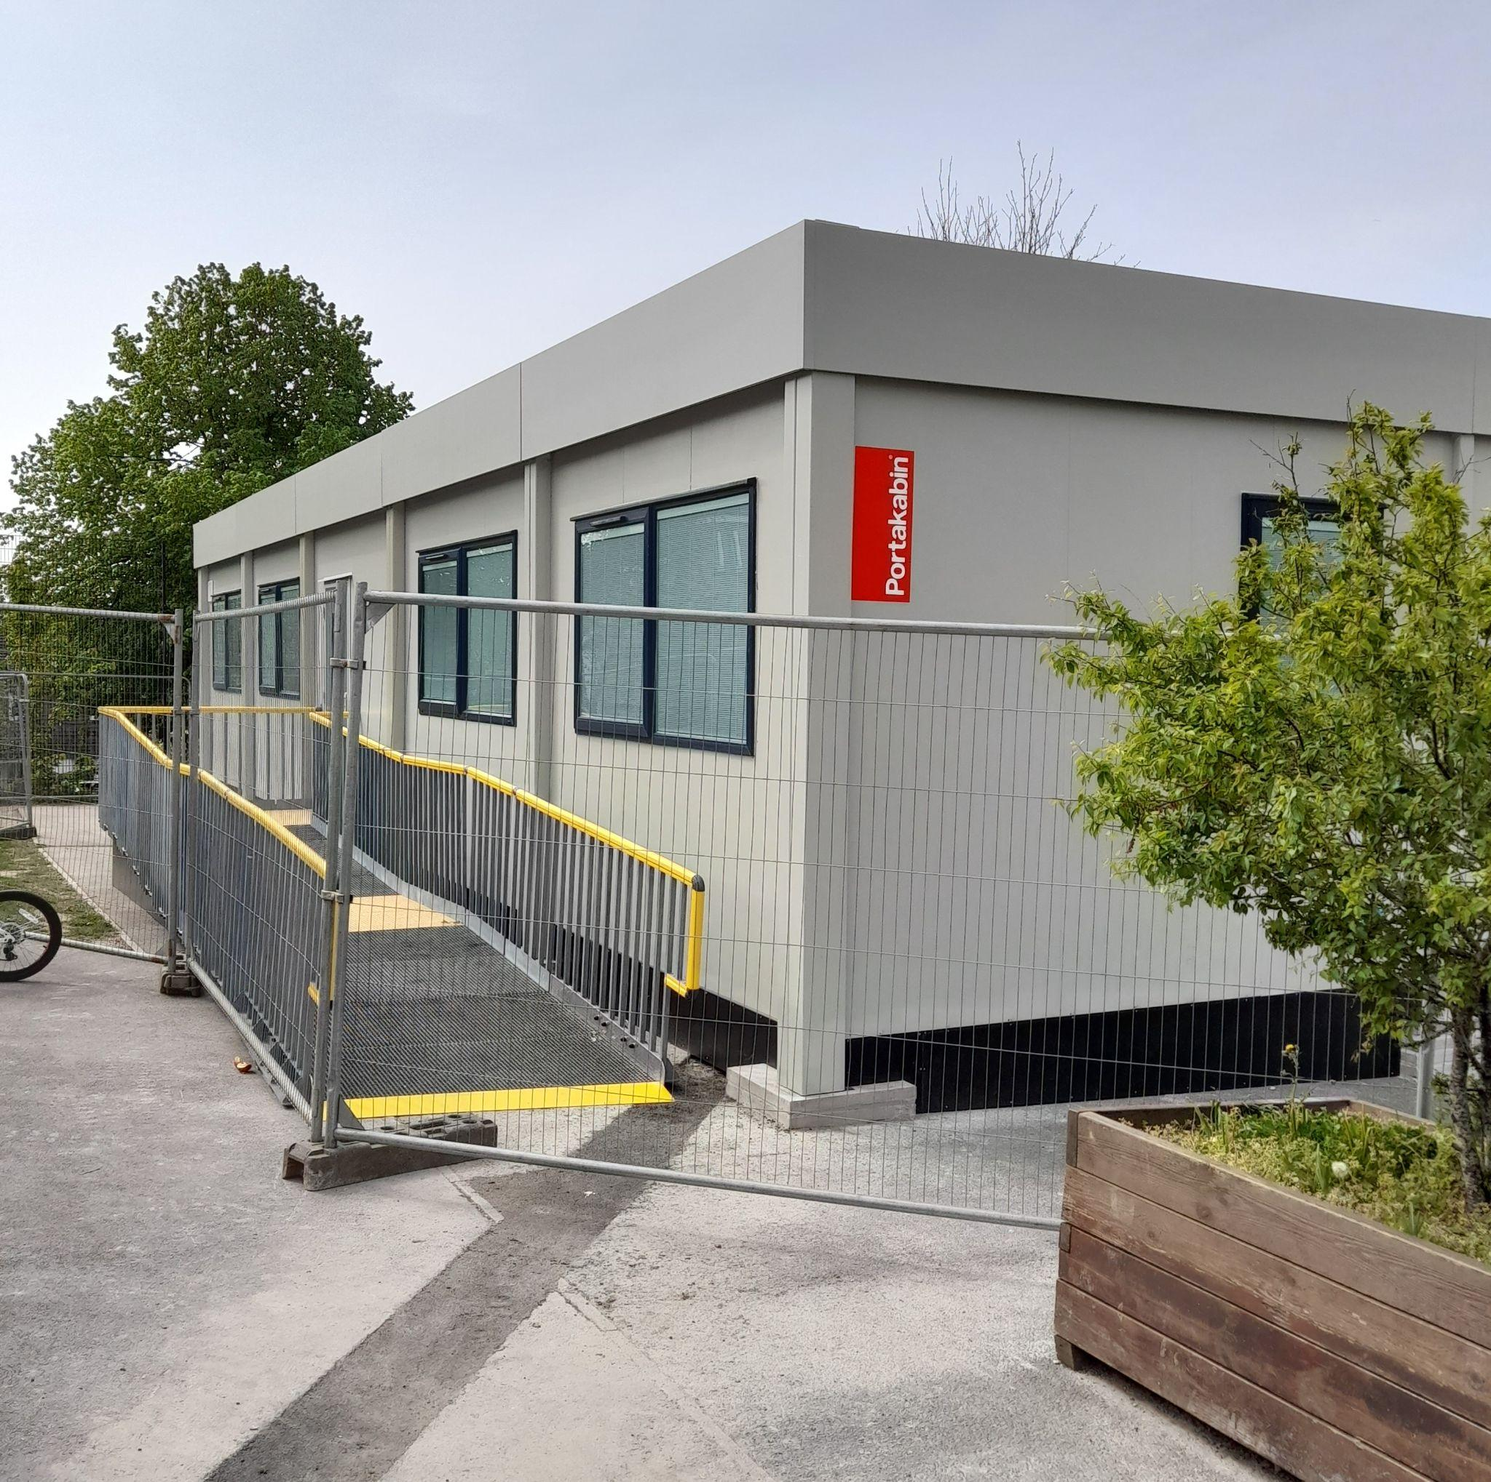
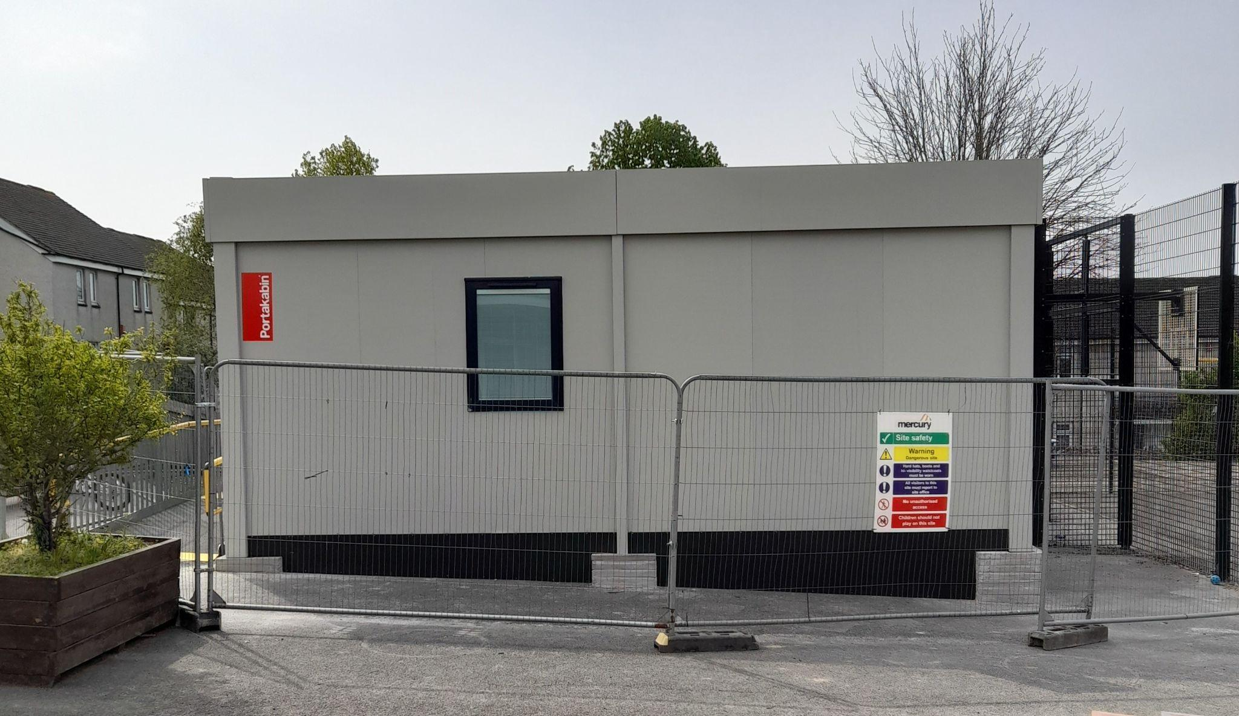
As I am sure you have seen, our new building arrived over the Easter holiday in the main playground. It is currently being finished internally so that we can have a super additional space for school very soon. The new building will ease pressure on space in the main school building and will be mainly used for some of our Inclusion team and provide a brilliant new area for children who attend our Nurture class and other additional provisions in school.
The building has 1 large classroom sized room and 3 smaller office spaces inside. The outside area around the building will be fenced in to enable a small, safe playspace to be made at the back. We can’t wait to be in there and using it.

Website Improvements – an Update
If you have read previous Newsletters, we have plans to update our school website so that it is simpler to navigate and provides parents and the wider community quick access to lots of key information. Our Trust has recently taken the decision to help all Reach South Academy Trust schools with their website designs and ongoing upkeep. Whilst this might delay our plans to launch a new website this term, it will mean that our finished product will be brilliant with every aspect of need covered. I have passed the outcomes of our parent website survey to the design team and I look forward to showing you the new website as soon as possible this year.

Attendance Concerns & Holiday Absence Requests
I hate to start the term with a moan but I am becoming increasingly concerned about the number of requests for holiday absence being made to school and the impact this is having on both children and the school. There has been a big increase in the number of children who are missing significant amounts of school time and having their education disrupted in order to have a holiday. I fully understand that holidays are important for families but children have 13 weeks of holiday time allocated each year with the expectation that they attend school for the remaining 39 weeks. It is a parent/carer’s legal duty to ensure their child is in school every day and I will continue to take action to issue Holiday Penalty Warning Notices and request Penalty Notices (fines) to parents/carers who persistently fail to ensure their child attends school. Many children have genuine reasons for not being able to attend school but any additional absence will cause interruption to education, not to mention the additional workload for teachers and school staff as they have to repeat learning with children to catch up. Please can I ask that holidays are not taken during term time at all and that all children attend school every day unless they are ill or have other medical reasons. Thank you.
Reminder: 100% Attendance Summer Challenge
All children who attend school for 100% of the Summer term will receive an attendance medal at the Governors’ Awards and will be able to join an afternoon picnic with games to celebrate their excellent attendance at the end of the year. I hope to see lots of children with attendance medals!

School Foyer - start and end of the day

We ask that parents and carers do not come into the school foyer between the time below whilst we have children from Year 5 and 6 entering and exiting the building:

Morning: 8.50 - 9.00 am
Afternoon: 3.15 - 3.20 pm

This is to avoid large queues at the office hatch whilst our older children drop off and pick up mobile phones. Parents/carers are asked to wait until the children have come into school or left at the end of the day before coming in to speak to our Admin team. We thank you for your cooperation with this.

We are proud of our learners!

Star Learners |  | Pat on the Back
YR1 JP | Autumn G | YR4 KP | Joyce L
YR1 MS | Travis F | YR4 ROL | Sarah T
YR2 TH | Mae L | YR5 SR | Tanisha G
YR2 RG | Patrick P | YR5 RH | Dan T
YR3 BF | Ace G | YR6 SS | Simon T
YR3 CB | Sulaiman L | YR6 LJ | Lily G

Community Messages

Pilgrim P.T.F.A. Meeting - We are looking for new members!

After 2 long years of pandemic, we are looking to get the Pilgrim Parent, Teacher and Friends Association off the ground again. The PTFA is a group of parents, teachers and friends of the school that works hard on behalf of the whole school community organising fun events to raise money for the children. In the past, the PTFA have run school discos, charity bake sales, fayres and lots more. It is a very sociable and worthwhile way of getting involved in school life - and we need YOU!
We would like to begin our PTFA meetings again, in preparation for our biggest event of the year - the Summer Fayre! We are hosting an open event for some of our new (and old!) parents/carers to come along and find out more about what it means to be a PTFA member. Whether you can offer a little or a lot of your time, please join us for a cuppa and a chat on Thursday (May 12th) at 2.30 pm in the main hall (please come to the main entrance). We hope to see as many of you there as possible as school events can only take place if we all work together to make them happen!

School Uniform Recycling - News from Mrs Harris - our Parent Support Advisor
We know how quickly children grow and how expensive buying school uniform can be! School is starting to hold a small stock of used school uniform items that have been donated to be put to good use. At the moment, we cannot guarantee all sizes or the full range of uniform items but it is a start! If you might be in need of uniform, please contact Mrs Harris or see her on the playground in the mornings.
Also, if you have any outgrown trousers, polo shirts, skirts or jumpers, we would be very happy to accept them to recycle to others. We hope that this initiative proves useful to our families and that our stock will grow over time.

After School Activity Clubs - spaces left
We still have some spaces in our after school activity clubs this term. If you would like to sign your child up for one or more of these clubs, please contact the office (01752 225319/ contactus@ppsonline.org) who will give you more details.

Activity club | Years | Day | Number of spaces
Multi Skills | 1 & 2 | Monday | 2
Argyle | 5 & 6 | Monday | 3
Athletics | 3 & 4 | Monday | 1
Art | 5 & 6 | Tuesday | 3
Singing | 2 | Wednesday | 7
Cricket | 5 & 6 | Thursday | 5
Girls Football | 4 & 5 | Thursday | 7
Football | 3 & 4 | Friday | 2
Netball | 5 & 6 | Friday | 2

Mental Health Awareness week 9-13th May 2022 - THIS WEEK!
The theme of the week this year is loneliness, so to raise awareness of the benefits of positive mental health we are going to be talking to the children about kindness, looking out for loneliness and what we can do to tackle it together. Then on Friday 13th May we are going to encourage children and staff to wear green mufti for ‘wear it green’ day. There is no donation required for this as it is a day to raise awareness and show our support. Please feel free to get involved by wearing something green on that day - anything such as a pair of socks, hair band or jumper (or come to school dressed in green from head to toe!).

Jelly Images - Class Photos and Sibling Photos (by request)

Our school photographer, Jelly Images, will be in school on the morning of Monday 23rd June to take Class photographs.
During the morning, Jelly Images will also be able to take sibling photographs (school siblings only) as we were not able to offer this in the Autumn term due to pandemic restrictions. PLEASE NOTE - sibling photos will only be taken by request. We will send out more information about how to book a sibling photo nearer the time.

Term Dates and Dates for your Diary

These are some of the main dates for this term - more to follow on our next Newsletters!

Summer Half Term: Monday 30th May 2022 to Friday 3rd June 2022
Year 6 SATs testing week: w/c 9th May
PTFA meeting: Thursday 12th May 2.30 pm
Wear Green for Mental Health: Friday 13th May
Non Pupil Day: Monday 6th June 2022
Pupils return from Half Term: Tuesday 7th June 2022
Sports Days (provisional): w/c 20th June
Parents Consultation Meetings: w/c 27th June
Summer Fayre: Friday 8th July
Governors Awards: Wednesday 20th July
Leavers Assembly: Thursday 21st July
Last day of Term: Thursday 21st July 2022

Here’s to a good couple of weeks and don’t forget to wear green to school on Friday to support Mental Health Awareness if you would like to.

Mrs L Meek
Headteacher

